Sheridan Dela Cruz
April 4, 2026
Module 2.3

ERD
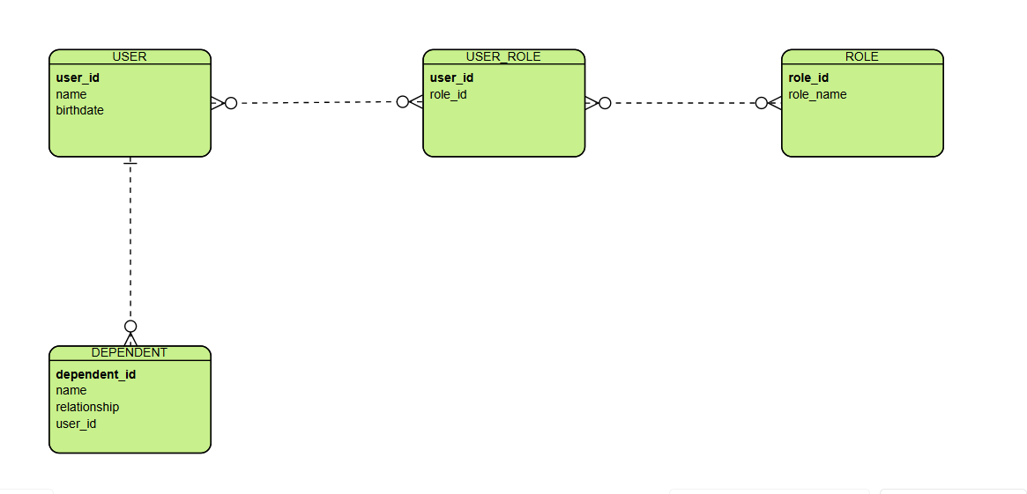

NoSQL
